Assignment 3 if for while conditions structure

Released Date: Oct 15th

Version 1.0

Format: Name the document in the combination of name、ID and No. of Assignment.

**Example: Ping Yi_23_Assignment1.doc**

**Email the document to “pingy@wxit.edu.cn” before Oct 18th.**

**Task 1** 4 LEDs are connected to Arduino Uno, try to use for cycle structure to make a 1s shift effect.

任务1 使用4个LED连接至Arduino Uno，尝试使用for循环结构，实现1s位移点亮的效果。

**You could use Tinker CAD or Proteus for the verifying.可使用在线工具Tinker CAD或Proteus进行仿真。**



**Fig 1 LED Shift Light**

|  |  |
| --- | --- |
| **1**  **2**  **3**  **4**  **5**  **6**  **7**  **8**  **9**  **10**  **11**  **12**  **13**  **14**  **15**  **16**  **17**  **18**  **19**  **20**  **21**  **22**  **23**  **24**  **25**  **26**  **27**  **28**  **29**  **30**  **31**  **32** | Answer**:**  //  int LEDblue**=**5**;**  int LEDred**=**4**;**  int LEDyellow**=**3**;**  int LEDgrenn**=**2**;**  void setup**()**  **{**  pinMode**(**LEDblue**,**OUTPUT**);**  pinMode**(**LEDred**,**OUTPUT**);**  pinMode**(**LEDyellow**,**OUTPUT**);**  pinMode**(**LEDgrenn**,**OUTPUT**);**  **}**  void loop**()**  **{**  **for(**int x**=**0**;**x**<**4**;**x**++){**  digitalWrite**(**LEDblue**,**HIGH**);**  delay**(**1000**);**  digitalWrite**(**LEDblue**,**LOW**);**  digitalWrite**(**LEDred**,**HIGH**);**  delay**(**1000**);**  digitalWrite**(**LEDred**,**LOW**);**  digitalWrite**(**LEDyellow**,**HIGH**);**  delay**(**1000**);**  digitalWrite**(**LEDyellow**,**LOW**);**  digitalWrite**(**LEDgrenn**,**HIGH**);**  delay**(**1000**);**  digitalWrite**(**LEDgrenn**,**LOW**);**  **}**  **}** |

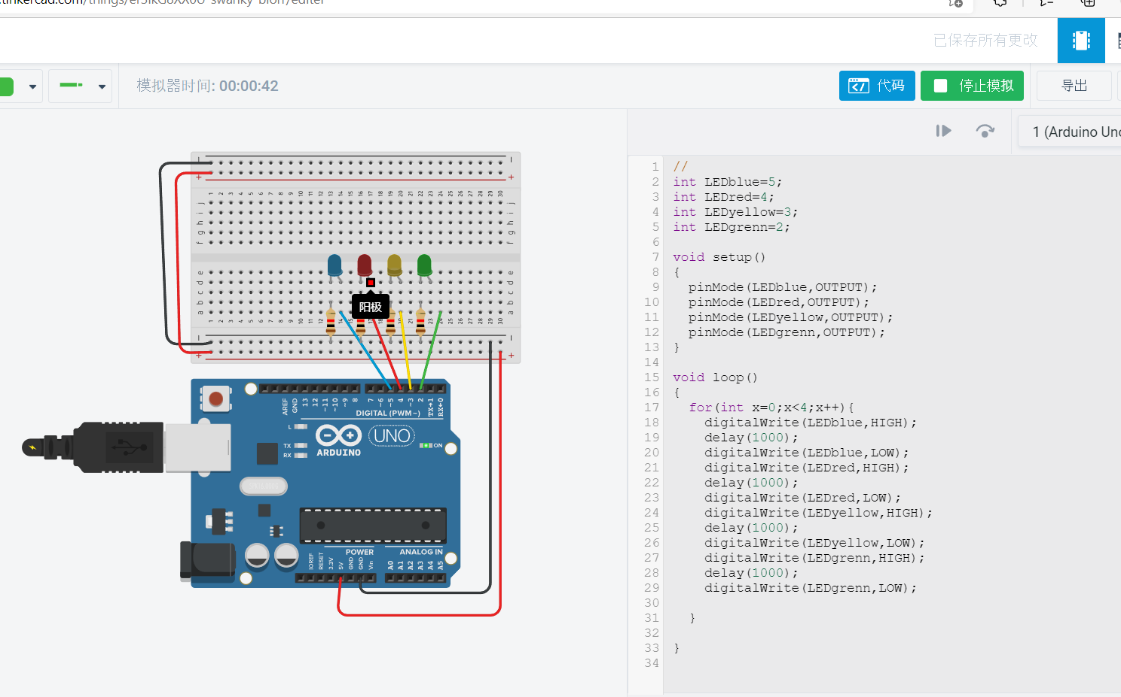

**Task 2** One LED and a POT are connected to Arduino, define a function named getVoltage to calculate the real time voltage of the POT, if the value is larger than 2.5V, then turn on the LED.

任务2 一个LED和一个电位器与Arduino Uno相连，定义一个函数名为getVoltage，用于计算POT段子的实时电压，若电压大于2.5V，则点亮LED。



Fig 2 LED Indicator

|  |  |
| --- | --- |
| 1  2  3  4  5  6  7  8  9  10  11  12  13  14  15  16  17  18  19  20  21  22 | int ledPin **=** 3**;**  int a0 **=** 0**;**  float val **=** 0**;**  void setup**()**  **{**  Serial**.**begin**(**9600**);**  **}**  void loop**()**  **{**  int sensorValue **=** analogRead**(**0**);**  float voltage**=** sensorValue **\*** **(**5.0 **/** 1023.0**);**  Serial**.**println**(**voltage**);**  delay**(**100**);**  **if(**voltage**>**2.5**){**  digitalWrite**(**3**,**HIGH**);**  **}else{**  digitalWrite**(**3**,**LOW**);**  **}**  **}** |